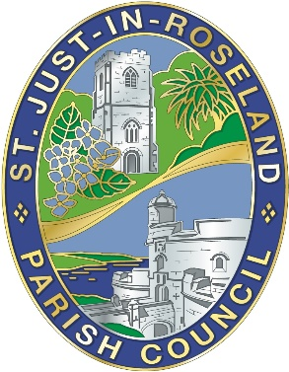

**St Just in Roseland Parish Council**

**Grant Funding Policy**

If you are thinking of applying for a grant, you will need to complete the application form, attach the relevant documents and take note of the following points. If you have any queries whilst completing the application, please contact the Parish Council office.

1. Each application will be assessed on its own merits/needs and will be considered along with other applications at a meeting of the Finance Committee. The Finance Committee will put forward recommendations at the next meeting of the Full Parish Council.
2. All applications must demonstrate clearly how a grant will be of benefit to the local community within the Parish, taking account of the protected discrimination characteristics listed within the Equalities Act 2010.
3. There is no automatic right to be awarded a grant. Grants will be awarded at the Parish Council’s discretion. All organisations will be required to complete the grant application form and submit the relevant supporting documentation, for the previous financial year.
4. The grant monies will be issued in the form of a bank transfer to the named or linked organisations account. Monies will not be released to an individual.
5. Parish Community Projects applications must demonstrate that the project is of benefit to the Parish and has the support of the local community.
6. Any grant awarded must be spent within any time scales given. Any monies not spent within the time scale must be returned to the Parish Council.
7. Within 6 months of receiving the grant, if requested, an update report must be provided and include copies of any relevant invoices. If the report is not received, the Parish Council has the right to request the monies are returned.
8. Applications will be considered from religious groups where a clear benefit to the wider local community can be demonstrated irrespective of their religious beliefs. Grants for the upkeep, maintenance or improvement of religious facilities will not be awarded.
9. Legislation (Local Government Act 1986 s2) does not allow grants to be awarded to political organisations.
10. The Parish Council may make the award of any grant subject to additional conditions and requirements, as it considers appropriate.
11. The Parish Council expect to see evidence of other methods of fundraising, especially match funding.
12. The Parish Council can offer letters of support for large projects that require other sources of funding.
13. Grants for retrospective applications will only be awarded at the discretion of the Parish Council.
14. Applicants must not change the use of their grant award without the written permission of the Parish Council.
15. Applicants must refer to the support of the Parish Council in any publicity they release and agree to the Parish Council publicising details of any grants awarded.
16. If applicants provide any false information in their application, this may lead to the withdrawal of the grant offer and a report to the appropriate authorities.
17. Persons signing the application form are required to make a personal guarantee that, should any grant offered not be used in accordance with the application, they will repay the outstanding amount to the Parish Council on demand.
18. Only one grant will be awarded in any one financial year.