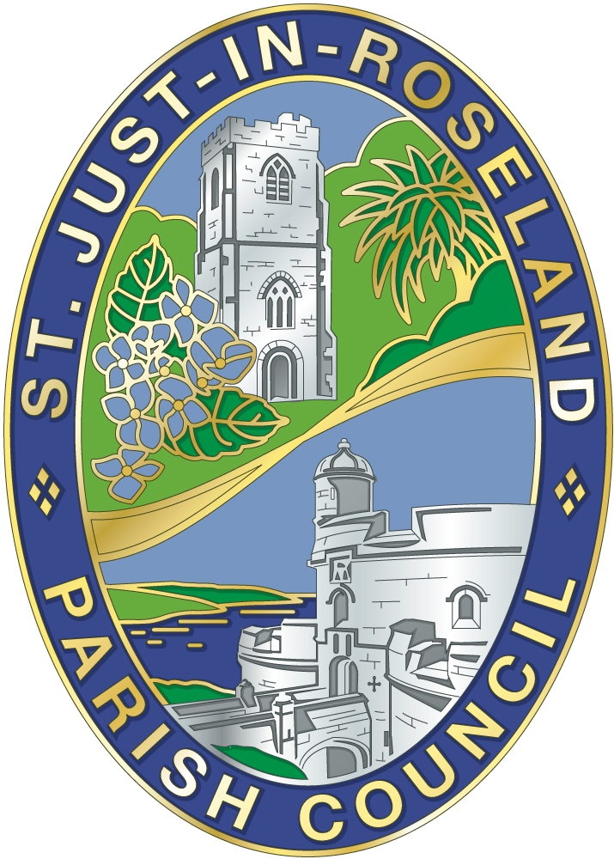
ST. JUST IN ROSELAND
PARISH COUNCIL
V.A.T. No. 527 0370 65

The Millennium Rooms, The Square, St Mawes, Truro TR2 5AG
parishclerk@stjustinroseland-pc.gov.uk Telephone: 01326 270799

NOTICE OF THE MEETING OF THE PERSONNEL COMMITTEE
To be held in the Millennium Room, St Mawes
Monday 21st July 2025 – 5.15pm

Todays date – 15th July 2025

All members of the Personnel Committee are hereby summoned to attend for the purpose of considering and resolving upon the business as set out in the agenda.

Please note that under the Openness of Local Government Bodies Regulations 2014 this meeting may be recorded.

AGENDA

- To accept apologies for absence

2. Declaration of Interest:
a) Disclosable Pecuniary Interest
b) Non-registerable Interest
c) Of gifts to the value of more than £25
d) To consider requests for dispensation on items on the agenda

3. Public Participation
Members of the public may address Councillors on any item on the agenda, for no longer than 3 minutes per person. This agenda item shall not exceed 15 minutes.

4. To confirm the minutes of the previous meeting held on 30th June 2025 and discuss any matters arising not on the agenda.
- Benchmarking of Parish Clerk Job
- Update on moving to another payroll provider

5. To review the following policies and make recommendations for Full Parish Council
- Social Media
- Complaints – defer to next meeting

6. To discuss any issues relating to staff, including work loads
- To discuss and note the spinal point range structure
- To discuss and note the pension scheme
- Contracts – defer to next meeting

7. Any other business that the Chairman considers to be of urgency

